appgsoutheast@secouncils.gov.uk

12th January 2022

Call for Evidence - written submission from the South East Local Enterprise Partnership

Dear Sally-Ann Hart, MP

I am pleased to attach below the South East Local Enterprise Partnership’s (SELEP) response to the APPG Inquiry: ‘Financing the future - what does Levelling-up mean for South East England?’.

SELEP is a business-led collaboration between private, public and education sectors, representing a large and diverse economy with a value of £94 billion. We have an excellent track record of strategic collaboration with local partners, with Government and with other LEPs to drive economic growth.

Within our Economic Recovery and Renewal Strategy we set out our significant opportunities for growth, particularly around our role as a global gateway and including our 2 new Freeports. However the Strategy also outlines the scale of the continued challenges we face, including significant skills deficits, variations in job density, lower levels of innovation spend and significant structural economic issues, particularly across our 365miles of coastline.

The future role of the LEP as a true and established partnership of public and private sector and academia in addressing these challenges and seizing economic opportunities is a vital one. Not least due to our comprehensive understanding of the local economy and the ability to identify areas of need and prioritise activity on that basis. Our response below outlines the role we have to play in supporting the Levelling Up programme and also the criteria that we believe would ensure that the programme focuses on the right issues and on the communities in most need.

I give my permission for this response to be placed on the webpage of the APPG and would be delighted to discuss our evidence and that of our fellow LEPs across the South East of England (the Catalyst South group) at a meeting of the APPG if required.

I wish you all the best with the APPG and look forward to hearing from you.

With best wishes

Adam Bryan
Chief Executive Officer
South East Local Enterprise Partnership

1. Is “Levelling-up” any more of a programme than the “Big Society” was?

Levelling-up has the potential to bring partners and resources together to address some of the deep-routed issues and inequalities that exist in communities across the UK. However, to be an effective programme it must:
- Be focused on areas most in need of levelling-up, based on clear evidence and not on nominal geographical boundaries
- Support long term investment and action to drive the economic conditions that will bring about the equality of opportunity that these areas are lacking
- Reflect the crucial role of the private sector in the delivery of the Levelling-up programme, which will be essential in driving the well-paid jobs and outcomes that are required to benefit local areas and the wider economy
- Build on successful partnerships and initiatives, and particularly those where the private sector plays a key role, promoting learning and collaboration and not competition
- Recognise the role of LEPs and the importance of regional strategic level economic development through public private sector partnership. This avoids being too parochial, as whilst important that solutions and actions are taken locally, if the drivers and solutions are too localised, economic opportunities could be missed as they may not provide the scale or environment needed to encourage sustainable private investment.

Levelling up has potential to be more economically focused and targeted in its ambition than Big Society, focusing on a root cause of societal challenge – lack of (well-paid) job opportunities and the skills and means to access these.

2. What should success criteria for Levelling-up look like?

While there is not yet a single agreed definition of Levelling-up, to ensure that this agenda creates opportunity for people and also greater equality in those opportunities across the country, it needs to be driven by the right metrics and success criteria.

At SELEP we do not feel that a focus purely on the economic performance of cities would deliver that equality of opportunity. Instead, it is important that the agenda reflects the core foundations of economic development - infrastructure, skills and education, employment opportunities, business support and innovation – building these foundations wherever in the country there is the greatest need.

The SELEP area covers Kent, Essex, East Sussex, Thurrock, Medway and Southend-on-Sea. Collectively it is an area of huge economic significance but also an area with much diversity in its economic opportunity and home to some of the most deprived areas in the UK.

130 LSOA across SELEP are in the 10% most deprived neighbourhoods in the country (IMD 2019), including the most deprived community in the UK, Jaywick Sands in Clacton. 106 of those LSOAs are found in SELEP’s 16 coastal districts. Districts with the highest percentage of deprived LSOA are Hastings 30%, Thanet 21%, Swale 19% and Tendring 18%. In addition, GDP per head in our coastal areas averages just £21,529 per head (2019) in contrast to the SELEP wide average of £26,738 and is below the performance of places such as Blackpool (£23,099), Bolton (£23,623) and Blackburn with Darwen (£23,885) all of which are recognised as economies requiring significant investment.
Perhaps the single biggest success driver, the ability for people to access well paid jobs, is a key challenge for many communities within SELEP and yet without the right metrics there is a risk that we are overlooked in favour of a narrative focused on cities or the north-south divide. SELEP has therefore created an index around four core metrics – job density, percentage of jobs in low paid sectors, sector skill levels and claimant count – which we feel identifies those areas in real need of Levelling-up. The analysis presents some interesting findings and highlights our case for a more granular look at levelling up and that it is driven by what people need most to lead healthy and gainful lives – well paid sustainable jobs – which ultimately drives the economic prosperity of an area.

We would be happy to share our wider analysis, but as a snapshot, using the metrics outlined above, a clear picture emerges in the SELEP area in which coastal and estuarine communities show the greatest level of need. Areas such as Hastings, Gravesham, Thanet, Tendring, Thurrock, Eastbourne, Dover, Folkestone & Hythe, Rother and Swale all score highly on this index and as the map below shows, are more in need of Levelling-up than many other parts of the country.

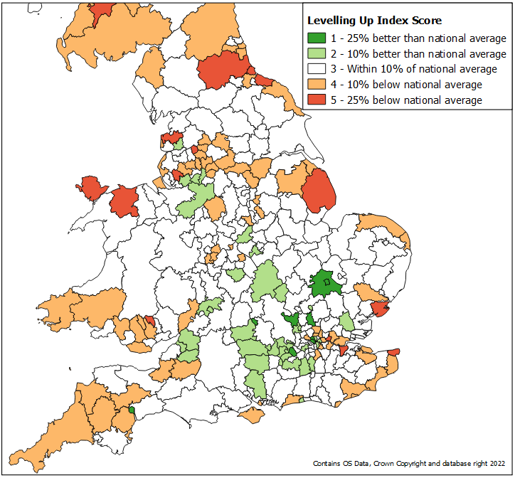

Our analysis shows that at a local authority level, 10 out of 32 authorities (34.5%) in SELEP need Levelling up.
Individual towns and local authorities may struggle to tackle these intrinsic economic challenges. They do not, for example, benefit from the scale and ‘attractive economic components’ which larger towns and Cities generally benefit from – business clusters, skilled labour, universities, transport links etc – which attracts investment and the ability to therefore evolve. Many towns need a renewed economic purpose and identity and require support in establishing this.
This is certainly true for our coastal areas where sectors like tourism and retail have significantly retracted over decades without, partly due to a lack of attractive components, being replaced by new sectors offering sustainable, gainful opportunities. The pandemic further highlighted this, with our coastal areas affected more than inland areas due to their reliance on these most heavily impacted, generally lower paid, sectors.
In September 2021 for example we saw a claimant rate (population aged 16 to 64) of 5.7% in our coastal areas compared to 4.0% in non-coastal areas. In addition, assessment of a range of economic and health indicators also showed that eight of SELEP’s coastal towns [Clacton, Dover, Folkestone, Harwich, Hastings, Margate, Ramsgate and Sheerness] suffer from both poor health outcomes and severe economic distress.
As the map illustrates, the levelling up challenges do not only lie in our coastal areas, but the combination of lower economic activity levels and associated high level of claimant counts in coastal areas is stark and not just a levelling up issue, but one of overall national prosperity. If GDP in coastal areas was brought up to match the SELEP average, the national economy would increase by up to £12 billion.
With the decline of their economic purpose, the lack of new opportunities emerging and the impact of Covid-19, some of SELEP’s coastal areas need to benefit from the Government’s Levelling-up policy and investment.

3. Must Levelling-up be an endeavour solely dependent on financial support?

No. Financial support and investment is a crucial part of Levelling-up, but in itself we believe that won’t fully address the challenge, especially if centred mainly around capital funding. The availability of such funding has not historically been the issue and whilst a vital part of the equation, some of the challenges reside in efforts being disjointed and/or largely public sector led. Rigid spending criteria, boundaries, duplication and short-term initiatives often cause real challenge in being able to effect long term change.

To be sustainable it is important that public investment supports and leverages that from the private sector. LEPs convene public private partners on a larger scale to not only share learning and resources but also to attract businesses and investment that will deliver the economic drivers that are most needed to support Levelling-up in the longer term.

SELEP for example work closely with our two Freeports to help bring together knowledge, expertise and resource from across the area to ensure that the outcomes driven by new commercial opportunities will support the needs of the many communities in need of Levelling-up that are located near the Freeport areas. Driven by commercial demand, the LEP plays a significant role in the case for and delivery of successful Freeports through its partnership and knowledge of the local economy.

The South East Major Projects Group is another example which sees multiple large major infrastructure projects across the region collaborating with each other, the LEP and its partners to create long term sustainable employment. Some projects can allocate existing resource to support activity, but the group facilitates a joined up regional approach. Both examples therefore ensure that activity isn’t disjointed and doesn’t layer more short-term initiatives that will fail to drive long term change in the areas that need it.

LEPs are also effective in ensuring that any financial support is utilised most effectively at a local level. Revenue funding for business support, including the Growth Hub service, to help businesses navigate the fragmented landscape, pays significant dividends in terms of business investment. It has the benefit of coordination and leadership at a SELEP level whilst local provision and delivery enables it to target areas and demographics most in need of support and harder to reach communities (such as coastal) to aid levelling up, and provide a unique interface between public, academic and business community investment.
4. Should councils be the vehicle to coordinate levelling up activity?

LEPs provide a ready alternative vehicle which is well placed to coordinate Levelling Up activity at scale and pace, with extensive engagement from across the public and private sector and including universities, colleges and business representative organisations.

LEPs are established vehicles focused solely on economic development. Well placed and with a successful track record in administering funding to support local growth, they also offer so much more – the in-depth understanding of the economy, evidence-based approach to activity, established public private partnerships and the ability to build that further, agility as a partnership to respond to and capitalise on opportunities presented by the private sector as well as economic challenges and a streamlined route for engagement with Government and other regional and national bodies.

SELEP provides the flexibility to adapt and work at a localised level to support our towns and communities, whilst creating the conditions for levelling up to happen at scale as well. This is particularly important in relation to attracting private sector investment. Many districts and boroughs are small in size and resource but often share similar characteristics and challenges with other areas. By supporting clusters of areas that have these common issues and opportunities we can present a more attractive proposal to the private sector, who don’t recognise political boundaries and must ensure return on investment. It can also avoid duplication, add value through shared practice and ideas and provide cost efficiencies in development and implementation. This is what clusters, such as the SELEP Coastal Communities Group (CCWG), can deliver.

The SELEP CCWG is a unique coastal partnership of 15 local authorities across Essex, Kent, and East Sussex. This group has successfully collaborated on the production of the ‘Coastal Communities Economic Prospectus – Boosting Coastal Productivity’ which outlines clear, ambitious proposals to seize new opportunities and ‘level up’ deprived coastal communities across the South East at scale.

This is just one group amongst many across SELEP. Partnerships across private and public sector work together to tackle issues around rural affairs, accelerating housing development, growing the role of social enterprises, encouraging clean and sustainable growth, promoting the role of the creative sector across communities and driving up skills needed to meet business demand, including our Digital Skills Partnership. This network of groups also provides existing collaborations to respond quickly and add value to local investments such as the Towns Fund and Levelling Up funds.

Similarly, SELEP works closely with our partner universities and local businesses to improve economic and social outcomes in our local areas through a range of other routes. Our U9 network brings together all the universities in the SELEP area, working together to focus and collaborate on activities and key policy issues, including supporting innovation and growth in key sectors that will benefit our local communities and stimulate greater economic opportunities and investment for the benefit of those communities.

Councils often play an important, and sometimes leading, role in these groups where it makes most sense for them to do so. But that isn’t always the case and that is the power of the LEP/partnership – the right partner organisation leading what they are best placed to lead. And with the combined and coordinated effort resulting in outcomes greater than that which could be achieved individually. For example, SELEP has successfully directed over £80million of ESF helping 42,000 into jobs and training, as well as our own £4.4million Covid-19 Recovery Fund Programme to support people and businesses recover from the pandemic.

SELEP’s federated’ model of operation provides public and private sector engagement and robust governance. Crucially it also enables decisions, where appropriate, to be taken at the level closer to the communities and businesses affected by those decisions.

All-cause mortality, child injury, preventable mortality, income and claimants

