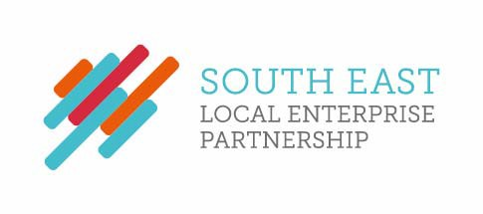
SELEP Hospitality Log

Graham Peters attended a private dinner at The Ivy in Brighton on Thursday 27 June 2019, hosted by Caroline Lucas MP, the Member of Parliament for Brighton Pavilion. This focused on how rail services can encourage travel to Brighton as well as improve connectivity in the local area. This was approved by CEO Adam Bryan due to its relevance to our agenda around East Sussex and the useful links that could be made.
Graham Peters attended the LEAP AWARDS DINNER sponsored by Lewes District Council and organised by E deal, 18th July 2019 at The View, Seaford Head.
Alex Riley attended the Annual Nuclear Industry Dinner 2019, on behalf of SELEP, as a guest of CGN on 5th December 2019. The ticket value was £314.40.
Sarah Dance accepted an invitation to a public lecture “Why Investment Pays” at Canterbury Christ Church University on Thursday 12 March 2020 with a dinner provided afterwards.
Christian Brodie toured the De La Warr Pavilion on the 26th August 2020 and received a book and bag to the value of £25 and a coffee.
Christian Brodie declined an offer received on the 20th May 2021 from Dover District Council worth approximately £900 to visit the open at Sandwich
Christian Brodie declined an offer received on the 28th June 2021 to attend the Open in Sandwich, Kent sent by The Open, worth approximately £900.
Sarah Dance declined an offer received on the 22nd June to attend Canterbury Cricket Week, sent by Kent Cricket and worth approximately £600.

