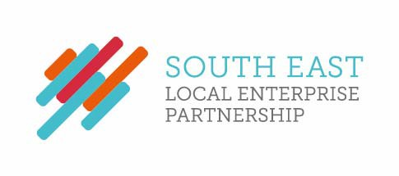
SELEP Expenses

Chris Brodie receives expenses of £20,000 annually as Chair of the Strategic Board.
Sarah Dance receives expenses of £10,000 annually as Deputy Chair of the Strategic Board

