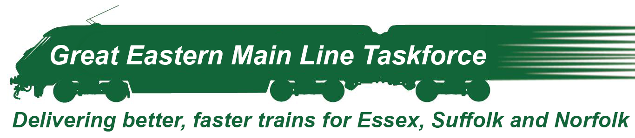

5 October 2020

Campaign for faster, more reliable train services in Essex – can you help?
I am delighted to have become Chair of the Great Eastern Main Line Taskforce, an important group I have worked with since my election three years ago. The Taskforce was created in 2013 by the Chancellor, to define the improvements we need if we are to have a rail service which is fit to meet the demands and ambitions of our international 21st Century economy. The Taskforce is led by local MPs working with Essex, Suffolk and Norfolk County Councils and the two Local Enterprise Partnerships.
The Covid 19 pandemic has demonstrated the need for resilient and adaptable infrastructure. Our rail service has really shown its value as commuting and work patterns change, operating excellently throughout these unprecedented times and providing essential transport for key workers across the region and moving essential freight around the country.
It is time to improve train service reliability, reduce journey times and attract new investment to ensure that our rail network has the capacity to enable growth. This is my focus as Chair of the Taskforce.
An infrastructure revolution is key to helping our region restart, rebuild and drive economic growth for the future and research has already shown that greater investment in the mainline to London could deliver £4.5 billion in wider economic benefits across our region, half of which would accrue in Essex. While the focus for investment is on the mainline where the railway line has significant constraints, the potential to deliver more frequent services, reduce journey times and improve reliability will benefit all users of the railway; connecting towns to each other, businesses to their suppliers and customers, and improving access to a wider range of employment opportunities.
We are delighted with the award of new trains we campaigned so hard to achieve and we look forward to the introduction of the new commuter trains later this year, which will transform services in Essex. However, the rail infrastructure is still severely constraining our railway services and I am fully aware there is still a long way to go before all of the benefits from rail service transformation can be realised.
Whether it’s for customers, staff, shoppers or suppliers, businesses or tourists, we need confidence that we have a rail service that is reliable, fast and fit for purpose – every hour of every day, 365 days of the year – if we are to continue to champion ourselves as a centre for global business excellence.
A new economic case for investment in the Great Eastern mainline is being finalised. This new economic case reflects forecast increases in rail demand, planned new housing and the economic growth that investment could bring. While the case will be strong, it will be tough to secure investment.
To make the case for investment as compelling as possible, we are looking to businesses across Essex to support us in our campaign. We would like to include case studies, anecdotes and quotes from businesses that illustrate the important role the railway plays in supporting the Essex economy and would like to invite you to join our list of signatures from CEOs that support our ambition.
Attached is a simple pro-forma which I would be very grateful if you could electronically sign and return before the end of October.

We look forward to hearing from you in due course and we will keep you in close touch with the progress of the campaign.
If you have any queries about this, please do not hesitate to get in touch with Alastair Southgate, Essex County Council, who has been assisting the project team on Alastair.Southgate@essex.gov.uk.
Yours sincerely

Giles Watling MP

