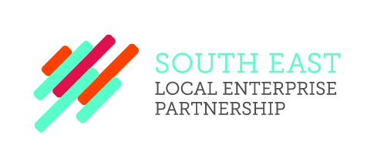
SELEP Expenses and Hospitality Log
Chris Brodie receives expenses of £20,000 annually as chairman of the SELEP Strategic Board.
Graham Peters attended a private dinner at The Ivy in Brighton on Thursday 27 June 2019, hosted by Caroline Lucas MP, the Member of Parliament for Brighton Pavilion. This focused on how rail services can encourage travel to Brighton as well as improve connectivity in the local area. This was approved by CEO Adam Bryan due to its relevance to our agenda around East Sussex and the useful links that could be made.
Graham Peters attended the LEAP AWARDS DINNER sponsored by Lewes District Council and organised by E deal, 18th July 2019 at The View, Seaford Head.

