Essex County Council
Request for Quotation (RFQ) Bidder Guidance

Essex County Council
Essex County Council (ECC) is dedicated to improving Essex and the lives of our residents. Our ambition is to deliver the best quality of life in Britain. We will achieve this by providing high-quality, targeted services that deliver real value for money.

Our vision
The Essex Organisation Strategy sets out our aims and priorities for the period 2017-21.
It articulates how we will achieve better outcomes for Essex and secure the ambitions set out in the Vision for Essex. Our ambition, at the end of this period, is for Essex to be the best local authority in the country.

At ECC we are passionate about better lives for people in Essex. We believe prosperity is the best route to achieve that – so people can help each other, and themselves. We are also ready to step in – to protect vulnerable children, to help care for older people and to support our economy to flourish. As a public body it is important we spend taxpayers’ money wisely, on the issues that matter to our residents. To offset reductions in government funding, we must constantly manage demand, reshape and re-imagine services and look for opportunities to generate income. It is also important we work tirelessly to secure investment into the county that can help make Essex an even better place to live and work.
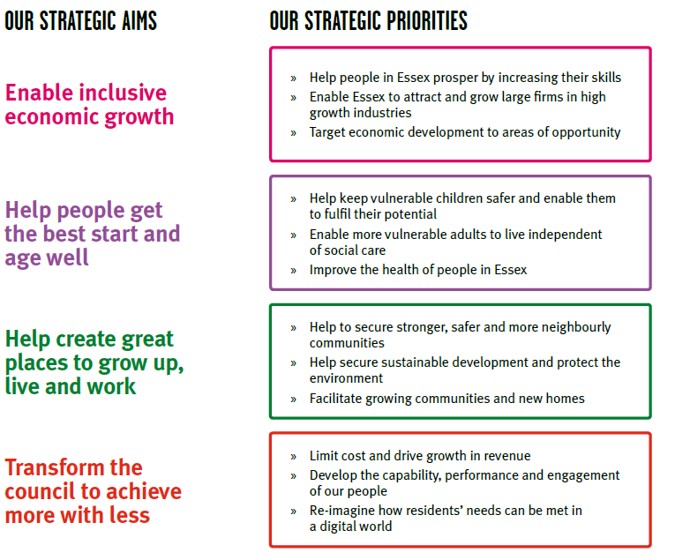
Further information can be found on the ECC website.
Our Principles
ECC has developed five key principles that will help us address these issues and that will underpin our development of the organisation strategy. These principles are designed not just to make ECC the best it can be, but to make Essex the best it can be – the future prosperity and wellbeing of our communities depends on getting this right.

- System Leaders
Our leaders are well networked and intuitively collaborative. We work together with partners to secure the “Essex we want to create” through public sector reform which results in the best outcomes for Essex and its residents.

- Enable & Empower
More often than not the Council is a facilitator. We add value by anticipating and, with partners, help shape the conditions for outcomes to be achieved. We empower people to support themselves and proactively influence and shape demand.

- Digital First
We embrace digital first at every opportunity either via direct service delivery or through partners. All interactions are optimised for a fast, accessible, user-friendly, inclusive and reliable digital experience.

- Collaborative
By default we collaborate with our partners, communities and residents, jointly designing the best solutions with them and being accountable to maximise the value for Essex people.

- Financially Self Sustaining
Having an innovative, commercial and entrepreneurial culture across the whole organisation, the Council is financially self-sustaining. We drive efficiency and create profitable income to enable Investment in services for Essex residents.

Content Table
No. | Section | Page
1. | Request for Quotation (RFQ) | 3/4/5
2. | Quality Questions & Specification | 5
3. | Terms & Conditions (T&Cs) | 5
4. | Clarifications | 5/6
5. | Evaluation | 6
6. | Insurance | 6
7. | Equality & Diversity | 6
8. | Modern Slavery | 6
9. | Supplier Charter | 7
10. | Information Governance (Data Processing) | 7
11. | Health and Safety | 7
12. | E-procurement | 7/8
13. | Pricing Spreadsheet | 8
14. | Freedom of information (FOI) | 8

- Request for Quotation (RFQ)
ECC invites you to submit a quotation for this requirement by E-mail. This document contains instructions and guidance that will help you work through the RFQ process.

Bidders must answer all the questions in the document called Specification and Quality Questions. If a question does not apply, then please write ‘Not Applicable’ and provide a brief reason why.

In consideration of the opportunity to participate in email RFQ’s held and conducted by Essex County Council (“Authority”), your company ("Bidder") agrees to the following information included within this document along with all RFQ documents such as the terms and conditions.
A. The Authority reserves the right to amend, modify or withdraw the email RFQ. The Authority reserves the right to accept or reject all or part of your proposal. The Authority is not liable for any costs incurred by the Bidder in the preparation, presentation, or any other aspect of the Bidder's bid. The Authority will not reimburse any expense incurred by you in preparing your bid. Bidders take part in this e-mail RFQ entirely at their own risk and cost.
B. All Bids which the Bidder submits through the email RFQ are legally valid quotations without qualification, except for data entry errors. All rates and prices quoted must exclude VAT and must be in sterling.
C. The Bidder shall keep the email RFQ content, other confidential materials provided by the Site and/or the Authority, and all bids provided by the Bidder or another participating organisation in confidence and shall not disclose the foregoing to any third party.
D. Bidders should ensure that they read and digest all of the required actions and appropriate deadlines and any subsequent communications. Bidders should not leave their response until the last minutes / hours before the deadline. (If you experience connection problems you will miss the deadline and your response may be deemed noncompliant and rejected by the Authority) If The Bidder experiences any difficulties during an email RFQ, The Bidder must notify the Authority immediately.
E. All communications, enquiries, questions or requests for clarification by Bidders should be addressed in writing to the e-mail on the front page of this RFQ document. Bidders should note that the Authority will not respond to any enquiry, question or request not submitted in this manner.
Bidders are referred to the front of the Specification and Question Document which highlights dates for the deadline for receipt of enquiries, questions and clarifications via email for further info see section 7
The Authority will respond to all reasonable clarifications as soon as possible and will circulate the Bidder’s questions and the Authority's response to them to all Bidders. If a Bidder wishes the Authority to treat a clarification as confidential and not issue the response to all Bidders, it must state this when submitting the clarification. If, in the opinion of the Authority, the clarification is not confidential, the Authority will inform the Bidder and it will have an opportunity to withdraw it. The Authority will deem that the question or request for clarification or further information has been withdrawn if the Authority is not contacted in writing within two Business Days following the Bidder being so informed If the clarification is not withdrawn, the response will be issued to all Bidders.; and should the Authority treat a question as commercially confidential information under the protocol described above, Bidders should be aware that this will not necessarily enable ECC to exempt it from disclosure under the Freedom of Information Act 2000 should a request for such information be made.
F. All parties will prohibit unethical behaviour and are expected to notify the Authority by contacting the appropriate ECC contact you are liaising with, if they witness practices that compromise the fair operation of the RFQ. Unethical behaviour will result in disqualification from the RFQ.
G. The terms and conditions of this element shall survive completion of the email RFQ.
H. Quotations for part or parts only of the service or for different standards or frequencies of service or made subject to alternative or additional terms or conditions may be rejected or may be rejected for the reasons of such alterations or additions only.
I. Bidders are expected to keep the RFQ quotation valid for acceptance for a period of 120 days from the RFQ closing date.

- Quality Questions and Specification
Open the document titled Quality Questions and Specification, read and understand the specification, complete all the questions listed below the specification and then save the document. When completing an RFQ, it is essential that the documents are sent back within the timeline stated on the first page of the Quality Questions and Specification document.

The level of detail required for the Requirement Specific Questions will vary based on the needs and complexity of the requirement. This is indicated by the page limits and/or word counts stated with each question. Responses will be evaluated to the stated limit, anything over this will be disregarded.

- Terms & Conditions (T&Cs)
The T&Cs applicable to the requirement have been included as part of the RFQ documentation issued and are ECCs standard T&Cs. Please note that any questions or requests to vary the terms of the contract including insurances must be raised by way of clarification before submitting your final RFQ response (see Clarifications section below). The Authority will not negotiate the terms of the Agreement after Tender award.

- Clarifications
Clarification questions on any element of the RFQ documentation can be raised during the clarification period (stated within the timetable on page one of the Specification and Quality Questions document) before submitting your final RFQ response.

The date range specified is when any clarification questions should be submitted as this will allow ECC to ensure answers are relayed in a timely manner.

No outstanding or new clarifications can be submitted as part of the bidder’s RFQ response. Clarification questions and queries should be directed to the ECC main contact email address that has been stated on the first page of the Specification and Quality Questions document.

- Evaluation
Please note, the Requirement Specific Quality responses will either 'Pass' or 'Fail' in line with whether, in our assessment, they have the capability and capacity to meet the minimum requirements set out in the identified evaluation criteria stated under each question. This assessment will be made through an evaluation of the answers provided to the questions asked in this document. If the minimum requirements are met, the response to the pricing question will then be evaluated. The bidder who submits the lowest price will be awarded the contract. You are welcome to request a blank Evaluation spread sheet to see the full process.

One example would be from the insurance question, If you cannot answer yes or willing to obtain, your quotation will not be accepted. ‘Yes, or willing to obtain’ along with details or a copy of the certificate is provided is a pass, and ‘No’ is a fail.

- Insurance
When working with ECC Bidders are required to have the appropriate insurances in place to mitigate risk. Please read the questions in the Specification and Quality Questions document and respond as appropriate.

If you cannot answer yes, or willing to obtain, your quotation may not be accepted.

- Equality & Diversity
Essex works to deliver services and products whilst paying due regard to the Public Sector Equality Duty in the Equality Act 2010. Equality is treating everyone fairly in accessing services and in the workplace. Diversity is acknowledging, recognising and celebrating difference between different communities.
We have provided a copy of ECC’s Equality and Diversity Policy as well as a link to the Equality Act 2010. Please familiarise yourself with the policies below before answering the relevant questions in the Specification and Quality Questions document.

https://www.gov.uk/guidance/equality-act-2010-guidance

- Modern Slavery
A link to the Modern Slavery Act 2015 has been included below. Please familiarise yourself with the Act below before answering the relevant question in the Specification and Quality Questions document http://www.legislation.gov.uk/ukpga/2015/30/contents/enacted

- Supplier Charter
ECC is committed to working collaboratively with its suppliers. The supplier charter is a statement of intent of the Councils commitment to our suppliers and conversely of the expectations we have of our current and potential suppliers.

- Information Governance (Data Processing)
Data protection is about ensuring information is processed appropriately. Protecting data is a legislative requirement under the Data Protection Act 2018. ECC and any suppliers engaged to undertake duties on behalf of ECC must comply with this Act or face potential fines or regulatory action. If you are successful in this RFQ process, we may require assurance of your compliance.
Here is a link to the Act: https://www.gov.uk/data-protection/the-data-protection-act.
We will require regular assurance that compliance with the Data Protection Act 2018is being undertaken if you are successful. Please find a link to some further guidance from the ICO: https://ico.org.uk/for-organisations/guide-to-data-protection/guide-to-the-general-data-protection-regulation-gdpr/
All Bidders must answer question 7.1 within the Specification and Quality Questions document.

- Health and Safety
ECC must adhere to the Health & Safety at Work Act 1974. Any Bidders supplying the Authority will need to do so as well. Here is a link to the Act: http://www.hse.gov.uk/legislation/hswa.htm

- E-procurement
ECC uses a Purchase to Pay (P2P) system to issue Purchase Orders and for Invoice Processing.

The questions in the Specification and Quality Questions document represent the minimum E-Procurement requirements and your response may be rejected if you are unable to comply. It is only in exceptional circumstances that a bidder may be granted an exception if they are unable to meet these minimum basic requirements.

Electronic Orders
As part of this contract, the Successful Bidder will be required to receive orders sent electronically (via P2P) to a central e-mail address, from the contract start date. Please find a link to the internet page for a full explanation of all e-invoicing options:
http://www.essex.gov.uk/Business-Partners/Supplying-Council/Pages/IDeA-Marketplace.aspx
Electronic Invoicing
As part of this contract the successful bidder will be required to submit invoices electronically via P2P from the contract start date.

- Pricing Spreadsheet
A pricing spreadsheet has been included as part of the RFQ documentation issued. Please complete the spreadsheet as per the instructions stated within the document.

Please note that only this document should be used to provide pricing information. The submitting of any other pricing information in any other document style will not be accepted and therefore seen as a fail in the evaluation process.

- Freedom of information (FOI)
ECC is subject to the provisions of the Freedom of Information (FOI) Act 2000. If you consider that any information supplied for the purposes of this RFQ is either confidential in nature or commercially sensitive (within the meaning of the FOI Act under sections 41 or 43, please see the guidance on exemptions on the information commissioner’s website on www.ico.gov.uk) this should be highlighted in your response to the relevant question in the Specification and Quality Questions document, along with the reasons for its sensitivity.

Please note that decisions on disclosure rest with ECC.

